Paper URL:

[Natural Noise Management in Recommender Systems Using Fuzzy Tools | SpringerLink](https://link.springer.com/chapter/10.1007/978-3-030-23760-8_1)

Paper Name: Natural Noise Management in Recommender Systems Using Fuzzy Tools

Category: Fuzzy User Centered

Location in PC:

"C:\Users\clari\Desktop\M2 - Thesis\Research\Dr Jacques Bou Abdo\Recommender System\0 - Papers\Noise Methods\Natural Noise Management in Recommender systems using fuzzy tools.pdf"

It’s about both individual and group recommendation systems

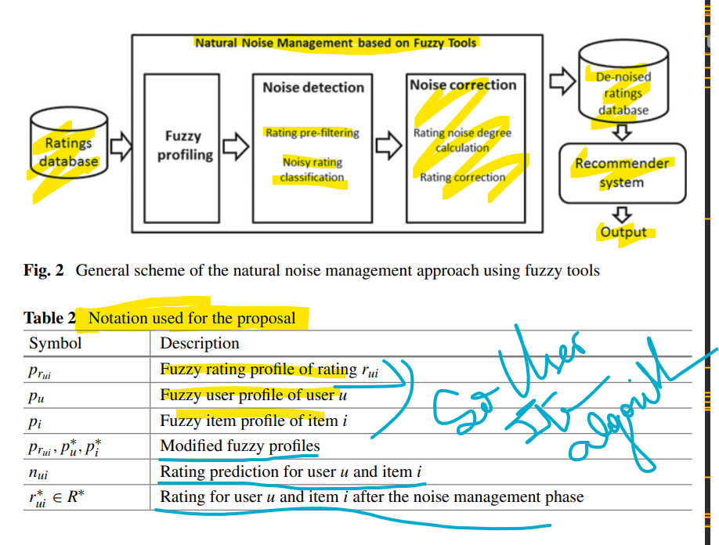

It profiles both users and items

So ha shila hotta gher mahal